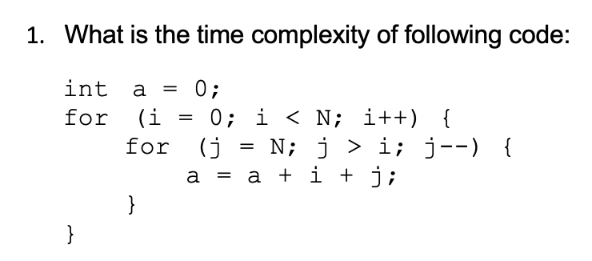

The time complexity is O(N2). This is a nested for-loop with the number of inner iterations depending on values in the outer loop.

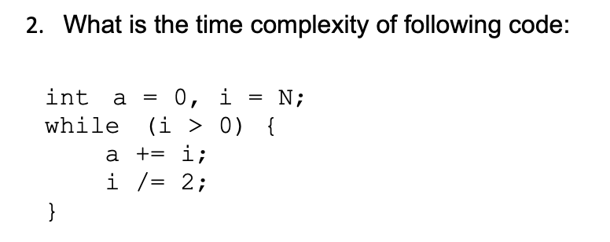

The time complexity is O(log(i)). The loop iteration amount depends on the halving of i.

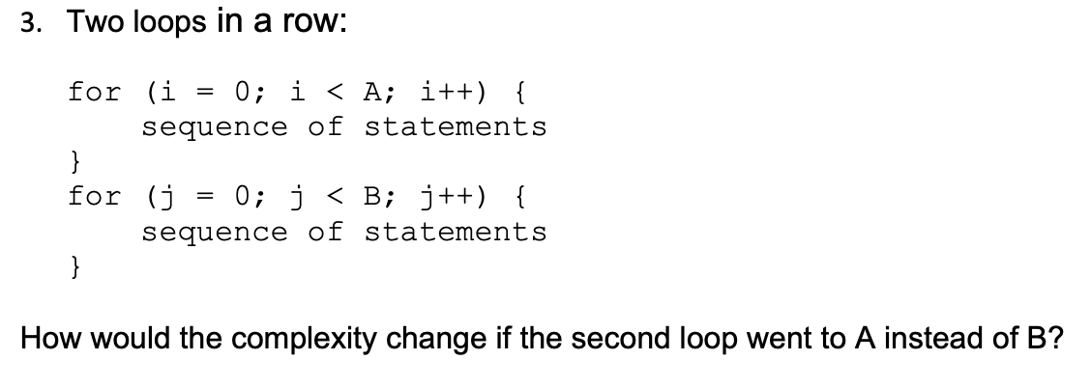

The time complexity is O(A + B),

If the second loop went to A instead, the time complexity is O(A + A) which would just be O(A).

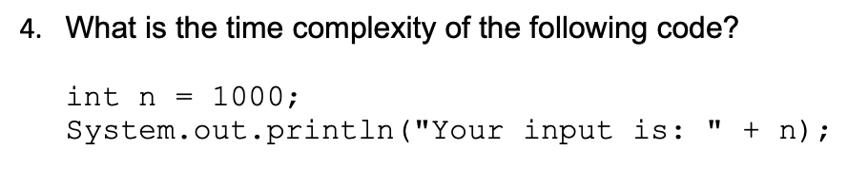

The time complexity is O(1). There is just a single assignment and print statement, so there is no algorithm here to have a variable time component.